Author: _________________________________________________________________
Editor: __________________________________________________________________
First Edit - Pay Attention To The Story
- Do we know where Bill started? YES or NO
  - If YES, write WHERE: ______________________________________________________
- Who is the first character Bill meets? ____________________________________________
- Does it make logical sense how Bill meets this character? YES or NO
- Is this character described? YES or NO
  - If YES, write one character trait to describe the character: _______________________
- Who is the second character Bill meets? _________________________________________
- Does it make logical sense how Bill meets this character? YES or NO
- Is this character described? YES or NO
  - If YES, write one character trait to describe the character: _______________________
- Who is the third character Bill meets? ___________________________________________
- Does it make logical sense how Bill meets this character? YES or NO
- Is this character described? YES or NO
  - If YES, write one character trait to describe the character: _______________________
- Are the events logical/Do they make sense? YES or NO
- Is there a clear ending where Bill ends up in Westlake? YES or NO
- Bill is the main character of the story, so the reader should know a lot about him. List THREE traits that describe Bill. Then, highlight the sentence that proves that Bill has this trait.
Trait #1: ________________ Trait #2:________________ Trait #3: ________________

Example: Trait #1: Curious
Then he looked at Sophia and saw her name tag. He took me to a strange place. He called the place Kristen’s house, but I wanted to learn more about it.
Second Edit - Pay Attention To The Grammar
SPELLING
- Highlight misspelled words in ORANGE
  - Pay attention to these TRICKY words
dollar bought goes used together could country carry thought always often walk again used know/knew once said mayor
GRAMMAR
- Are all sentences complete thoughts? YES or NO
  - Practice: Rewrite the incomplete thought below so that it is a complete sentence.
    - Right into a dog’s mouth! _________________________________________
- Does every sentences start with a capital letter? YES or NO
FLOW
- Does the story use transition words to connect ideas? YES or NO
  - Example of transition words:
  - 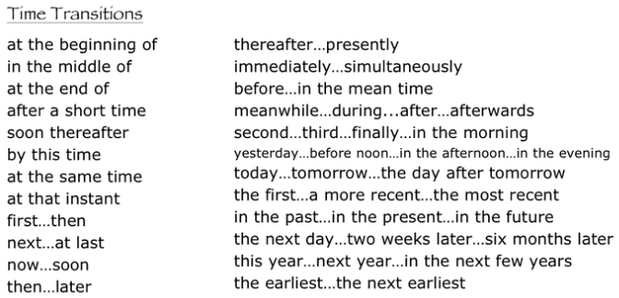
- Evaluate the article on its easiness to read: _______________
1 – Choppy, confusing, disconnected ideas, no transitions
2 – Some connection between ideas, still a few jumps
3 – Flowed nicely, all ideas connected with transitions

- What was your favorite part of the story? ___________________________

